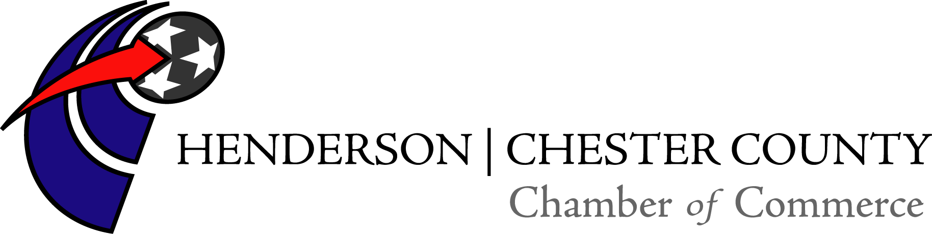

15th Annual Chamber of Commerce Golf Tournament
Sponsored by Lonnie Cobb Ford
Friday, April 27, 2018
Breakfast starting @ 8:00am sponsored by Stacy Smith and Mayor Dwain Seaton
Shotgun start at 9:00am
Lunch provided
Chickasaw Golf Course
Henderson, Tennessee

Golf Team and Hole Sponsor $325.00
Four-man team, which includes breakfast & lunch, green fees, cart rental and a hole sponsorship.

Team of Four $275.00
Four-man team, which includes breakfast & lunch, green fees, and cart rental.

Hole Sponsor $75.00
Hole Sponsor includes a sign with your name or company name next to a hole the day of the tournament.

Exclusive Hole Sponsor $125.00
With this sponsorship level it ensures that you will be the only sign and sponsor of a hole on the day of the tournament.

“Deal of the Day” available for $20.00 per player and includes 3 mulligans, one red tee, and one door prize ticket. Can be pre-purchased or purchased the day of the tournament.

Join us for a fun day of golf, friends & food!
Hole-in-One contest sponsored by Teague-Noles 45 Auto Mart of Henderson, TN

15th Annual Chamber of Commerce Golf Tournament Registration Form
Friday, April 27, 2018
Breakfast at 8:00 am sponsored by Stacy Smith and Mayor Dwain Seaton
9:00 am Shotgun Start
Lunch provided
Chickasaw Golf Course

Name of Team:_________________________________________________________

Player 1:________________________________________________________________
Player 2:________________________________________________________________
Player 3:________________________________________________________________
Player 4:________________________________________________________________

Team Contact Name :_________________________________________________
Team Contact Phone Number:_______________________________________
Team Contact Email Address:________________________________________
Team Contact Mailing Address:_________________________________________________________________________________

Circle Total Amount Enclosed: (Cash or Check only)

$325.00 Team and Hole Sponsor

$275.00 Team Only

$75.00 Hole Sponsor

$125.00 Exclusive Hole Sponsor

For more information, please contact the Chamber office at 731-989-5222 or email channing@chestercountychamber.com

Please register your team by April 20, 2018. Please turn in information for hole sponsorship by April 13, 2018. Remit payment and registration form to the Henderson/Chester County Chamber of Commerce, PO Box 1976, Henderson, TN 38340.

