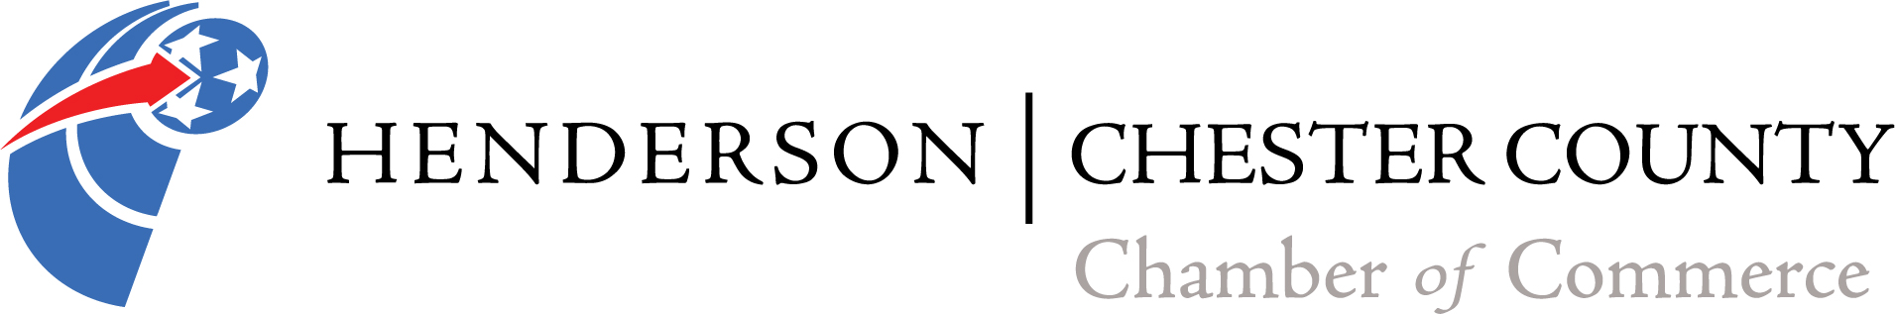

16th Annual Chamber of Commerce Golf Tournament
Sponsored by Lonnie Cobb Ford

Friday, April 26, 2019
Breakfast starting @ 8:00am sponsored by County Court Clerk- Stacy Smith and
Chester County Farm Bureau- Charles Cavaness
Shotgun start at 9:00am
Lunch provided
Hole-in-One contest sponsored by Teague-Noles 45 Auto Mart of Henderson, TN
Chickasaw Golf Course
Henderson, Tennessee

Golf Team and Hole Sponsor $325.00
Four-man team, which includes breakfast & lunch, green fees, cart rental and a hole sponsorship.

Team of Four $275.00
Four-man team, which includes breakfast & lunch, green fees, and cart rental.

Hole Sponsor $75.00
Hole Sponsor includes a sign with your name or company name next to a hole the day of the tournament.

Exclusive Hole Sponsor $125.00
With this sponsorship level it ensures that you will be the only sign and sponsor of a hole on the day of the tournament.

“Deal of the Day” available for $20.00 per player and includes 3 mulligans, one red tee, and one door prize ticket. Can be pre-purchased or purchased the day of the tournament

16th Annual Chamber of Commerce Golf Tournament Registration Form
Sponsored by Lonnie Cobb Ford
Friday, April 26, 2019
Breakfast at 8:00 am
9:00 am Shotgun Start
Lunch provided
Chickasaw Golf Course

Name of Team: __________________________________________________

Player 1: ________________________________________________________
Player 2: ________________________________________________________
Player 3: ________________________________________________________
Player 4: ________________________________________________________

Team Contact Name: ______________________________________________
Team Contact Phone Number: ______________________________________
Team Contact Email Address: _______________________________________
Team Contact Mailing Address: ______________________________________

Circle Total Amount Enclosed: (Cash or Check only)

$325.00 Team and Hole Sponsor

$275.00 Team Only

$75.00 Hole Sponsor

$125.00 Exclusive Hole Sponsor

For more information, please contact the Chamber office at 731-989-5222 or email channing@chestercountychamber.com

Please register your team by April 12, 2019. Please turn in information for hole sponsorship by April 15, 2019. Remit payment and registration form to the Henderson/Chester County Chamber of Commerce, PO Box 1976, Henderson, TN 38340.

